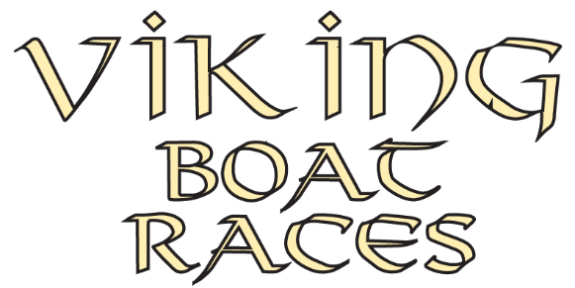
In association with
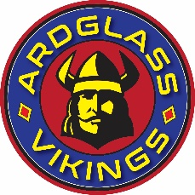

22nd Annual Fundraising
Sunday 25th August 2024
Cutters Wharf, Stranmillis, Belfast

In aid of NSPCC Northern Ireland

I wish to enter a team for the Viking Boat Races:

Name of Team: …………….……………………………………………………..……………...………………

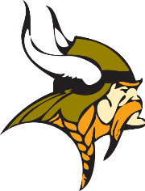
(Please Print)

Male Team (10 Rowers)
Female Team (10 Rowers)
Mixed Team (5 Male/5 Female)
Team Category (tick (Please tick 1 box only)

Name (Team Captain): ……………………..………………….……………..…….……………….………………………

Address: ……………………..………………………………...……….………………….……….…………………….…..

…………………….………….………………………………………Postcode …………...……………………

Telephone: ………….…………………..……..…………. Email: ………………………………………..……………….

Registration Fee per Team is £30.00 and this can be paid a variety of ways:

- Cheques can be made payable to NSPCC NI
- Bank Transfer; Bank account no 70309745, Sort code 950121
Ref ‘CVBR and Team Captain surname’
- Credit/debit card payment details please telephone 028 2044 1568

Each team will be asked to raise a minimum of £500 in sponsorship.
Raise over £750 and you will each receive free BBQ food, a free drink and lots of other goodies.
£500 will enable Childline Counsellors to answer 125 contacts and £750 will enable counsellors to answer 175 contacts from vulnerable children and young people who need support.

We would love to help and support you with your fundraising. Please tick this box to agree
that you are happy for us to forward your details to the local fundraising team at NSPCC Northern Ireland
so that they can supply you with sponsor forms and additional fundraising tips for this event.

Book early! Remember there will be Prizes for Best Dressed Team!
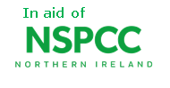
Return your completed registration form by Friday 11th August
to djackson@wineinns.com or post FAO David Jackson,
Wine Inns, 3 Duncrue Place, Belfast, BT3 9BU
Thank you. Will be in touch shortly

